GUIDE TO AGM ONLINE WEBINAR
Before the day of the AGM, you NEED TO REGISTER. Upon registration, you will receive the Zoom link to the online webinar.
Before you begin, the “Zoom” app can be downloaded free from your phones App store.
You do not need the app to join the webinar
Step 1
If you have the Zoom app, press Ctrl and Click on the link below.
https://us02web.zoom.us/webinar/register/WN_i_7AOvQTQ6ORS0FuKd8b-A

OR

Copy the link and post into your browser
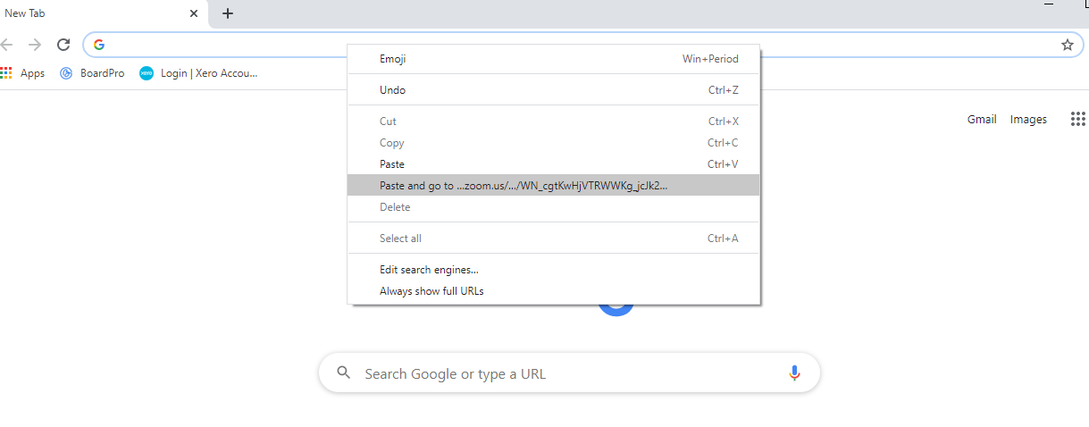

Step 2

Complete the registration form

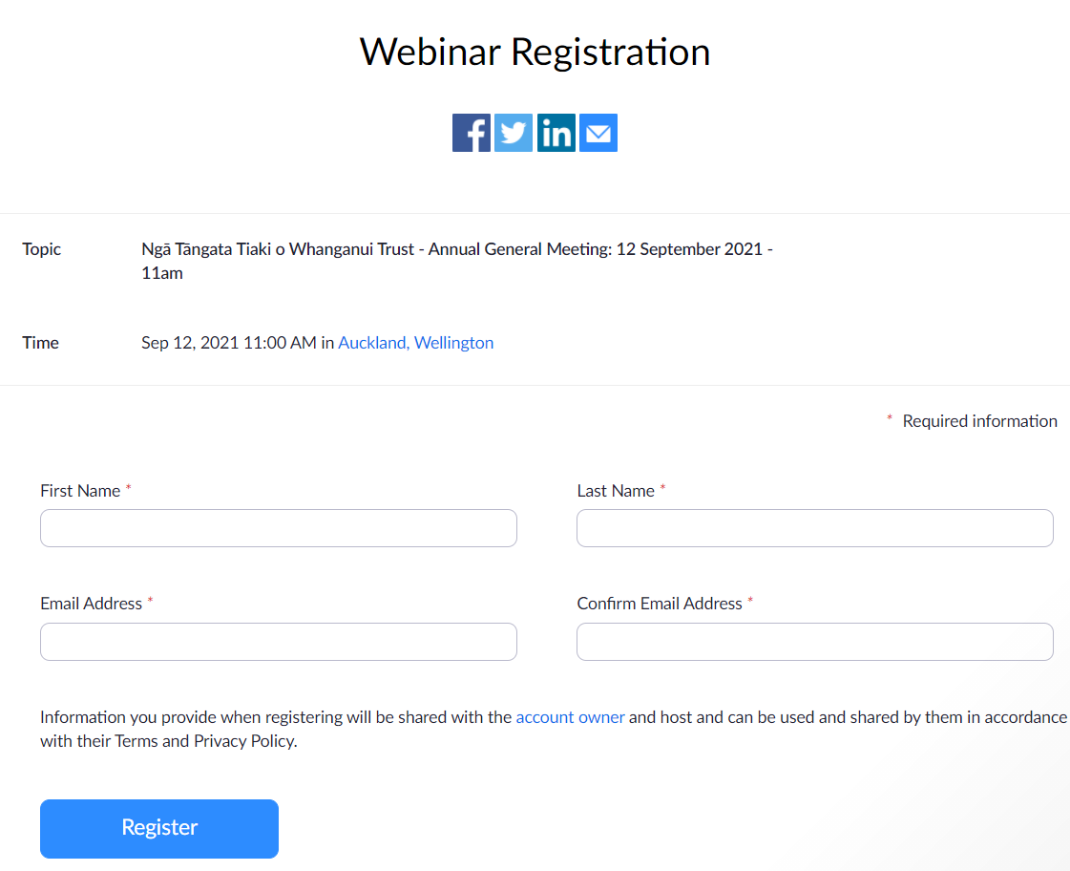
Step 3
A confirmation email will be sent to your registered email address confirming the link and webinar login details.
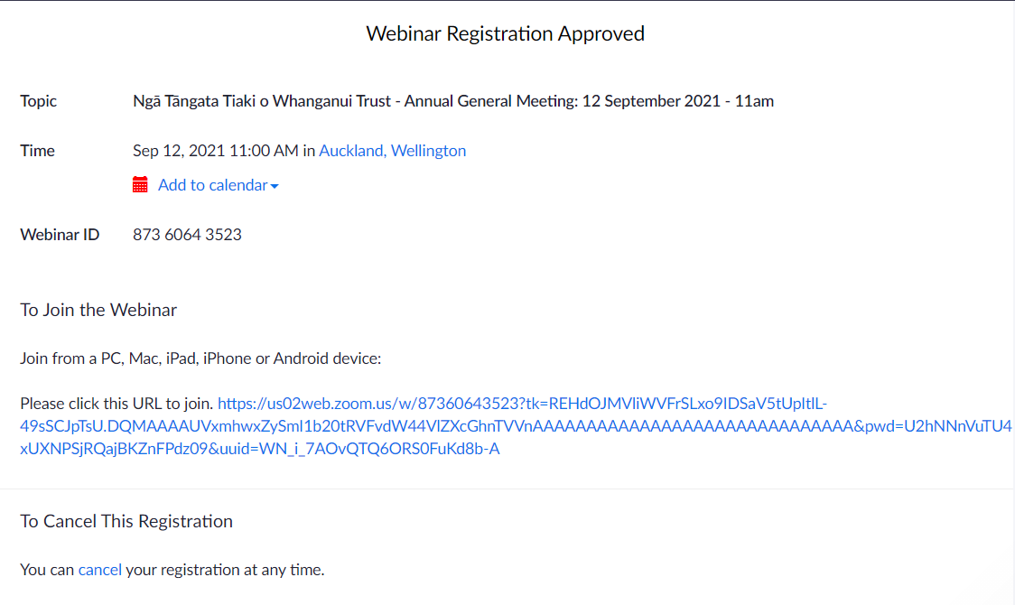

DAY OF AGM
Click on link sent to your email to join the webinar. 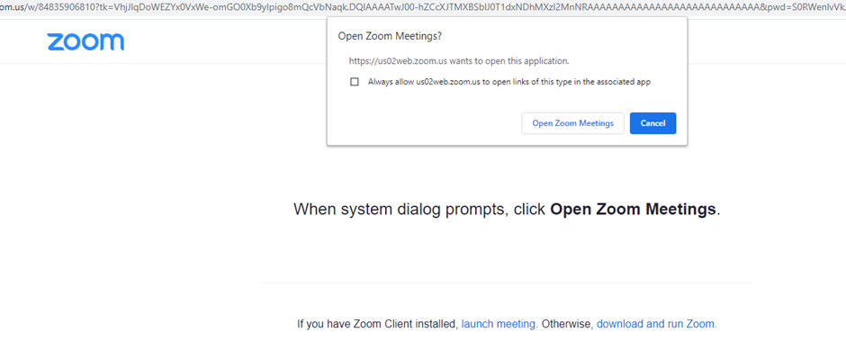
You are ready to watch the webinar.
ASKING QUESTIONS
If you wish to ask questions during the webinar, use the Q&A tab.
Alternatively, you can submit any questions by email either before or after the AGM to office@ngatangatatiaki.co.nz

VOTING
- Only those adult (18 years of age or older as at 12 September 2021) registered members on the Whanganui Iwi database are able to vote.
Each of the resolutions to be considered at the AGM are in the polling section of the webinar.
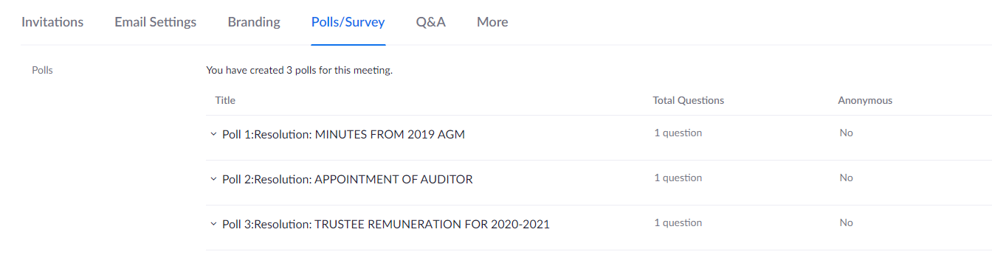
How to vote…..
When voting, select either YES or NO to each of the resolutions.

